ANSE International Intervision group
„Advantages of Differencies“
2008- 2013
Who we are (on the picture from left):
Markos Perrakis ( Greece)
Elisabeth Alder- Wuerrer ( Austria )
Signe Vesso ( Estonia)
Natalija Dievina (Latvia )
Kaupo Saue ( Estonia)
Annie Hoekstra ( Netherlands)
Andris Dievins ( Latvia )
We are members from 4 different national associations.

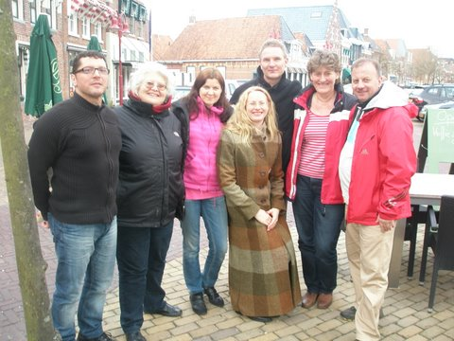
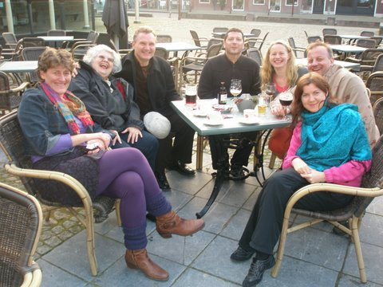
Some pictures from Netherland 2011, taken with Natalija´s camera.
Fun has always been an important ingredient of our meetings.

How did it started?
We met each other and it all started in Tallinn, ANSE Summer University, summer 2007, from our homegroup. We liked each other and decided to start an intervision group. Next spring Sissi invited us to Wienna to her cosy home. There we made a contract and found a name for us. The name is an important one, it has a magic inside. Where your focus goes, there your energy flows. We have learned a lot from our differences and it is still an ongoing process. Markos joined us in November 2009.
Goal:
Our goal was to find ways of using the advantages of our differences in personal development and common work for better solutions in our professional cases.

How many meetings we had?
We have had 10 meetings altogether, 2 meetings every year, hosting collegues by turns in the members countries.
Connecting the dots:
Steve Jobs said at Stanford commencement speech:
"You've got to find what you love. Again, you can't connect the dots looking forward; you can only connect them looking backwards. So you have to trust that the dots will somehow connect in your future. You have to trust in something — your gut, destiny, life, karma, whatever. This approach has never let me down, and it has made all the difference in my life.“
Our reflections- what are the connected dots for us, what was meaningful and important for us during our journey?
Contract:
- Initial contract to work for 5 years was very detailed and crucial.
- It helped alot to step out of a frame in several ways
Place:
- We were hosts in turns
- We always stayed together in one place, it was very special way to learn to live together.

Changes in life:
- These 5 years were successful years, started my own business, children grew from students to adults
- This period has been significant for my life- marriage, child, house
- Personal and existential level – changed a job, found a family, developed new platform for life

Culture:
- We succeeded making a third culture
- We got intercultural behaviour experiences
- Going to abroad and seeing different countries, ( not from a tourist point of view) we understand now our own culture better
- I value especially experiences of intercultural behavioural differencies
- It deepened understanding of differences
- I had no relatives in those countries- now my picture of european culture is wider
- Developed unique culture awareness of every country
- Learned about my own culture through other cultures
- Opportunities to travel to other cultures
- Learned a lot through ( family-, life-)stories
Relationships:
- We established deep relationships with each of us, based on significant support for personal and professional growth
- Being together increased acceptance, tolerance and understanding
- I understood how to build trust and create understanding
- Learned to trust different people from different countries
- I learned to trust other people and their ways to do things
- It served also often as therapy group
- Learnings about realtionships and trust
- Always, included meantime, available support + solutions
- Importance of fights, time and space for that- we went through, didn’t get stuck in groupconflicts
- Importance of laughter
- Learning to love groupmembers and other cultures
Professional and personal development:
- Learned different methods and practices
- Got deep, very hot and valuable experiences with unsuccessful projects
- We managed successfully that 5 years project together
- Learned to trust different processes to reach results
- Got aware and reflected on my professional dogmas- ways how to handle things
- Got energy to move in many directions
- Got many things you can´t learn in courses
- It influenced my identity- I grew as a supervisor
- Became a Head of Estonian supervisors from the first meeting. My task is to help them grow. Established International Supervision and Coaching Institute
- Awareness of what I want in professional and personal life
- Time for stepping out of our doing wheel and to reflect on ideas and actions
- Learned about professional cultures of different countries
- That supportgroup helped me to create a stability- that stays with me
- Personal dreaming and goal setting
- Regular time out to look at myself and meet myself from different perspectives
- Living far away maked it possible to work through deep personal cases
- Our group is a huge laboratory if ideas
Other successful common sideprojects :
- Sissi lead a leadership training for Enterprise Estonia mentorprogramme mentors.
- Andris and Markos were involved in a management development programme for a Estonian construction company branch in Latvia.
- Markos lead „Appreciative coaching“ seminar to Estonian supervisors and coaches.
- Annie lead „Practical supervision and coaching tools from Netherlands“ seminar to Estonian supervisors and coaches.
- Signe and Kaupo were involved in Sissi´s „bridge building“ 2 years project „Educating Supervisors and Coaches for Multicultural Europa“, where we lead seminars in different countries.

What now?
We will continue as a post –intervision group with the possibility of change or stop it under common agreement.

At first we decided to go on with one meeting per year and to choose a country for our meeting which is not one of our homecountries.
That meeting will be in October 2013, Antibes, France.
You´ve got to do what you believe in, thats what matters.
We believe in intervision groups, thats why we continue.

Text mainly cocreated by all of us,
composed by Kaupo Saue

